Sign up Here!

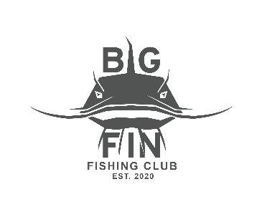

________

DO NOT MISS ALL THE FUN!
________

Leadership, Teamwork, Faith and Football
_______

The Class Will Be Taught By Coach Suttle
Big Fin Flag Football

Did you know that flag football is the fastest growing high school sport? Develop your skills with this exciting program developed by Zach Demarius, head flag football coach at Life University. This faith based class will help develop teamwork, leadership, and football skills.
1st – 5th Grade
February 4– Tuesday, April 22
$265Total

Questions? Contact Zack Cook at bigfinfishingapparel@gmail.com

