    - 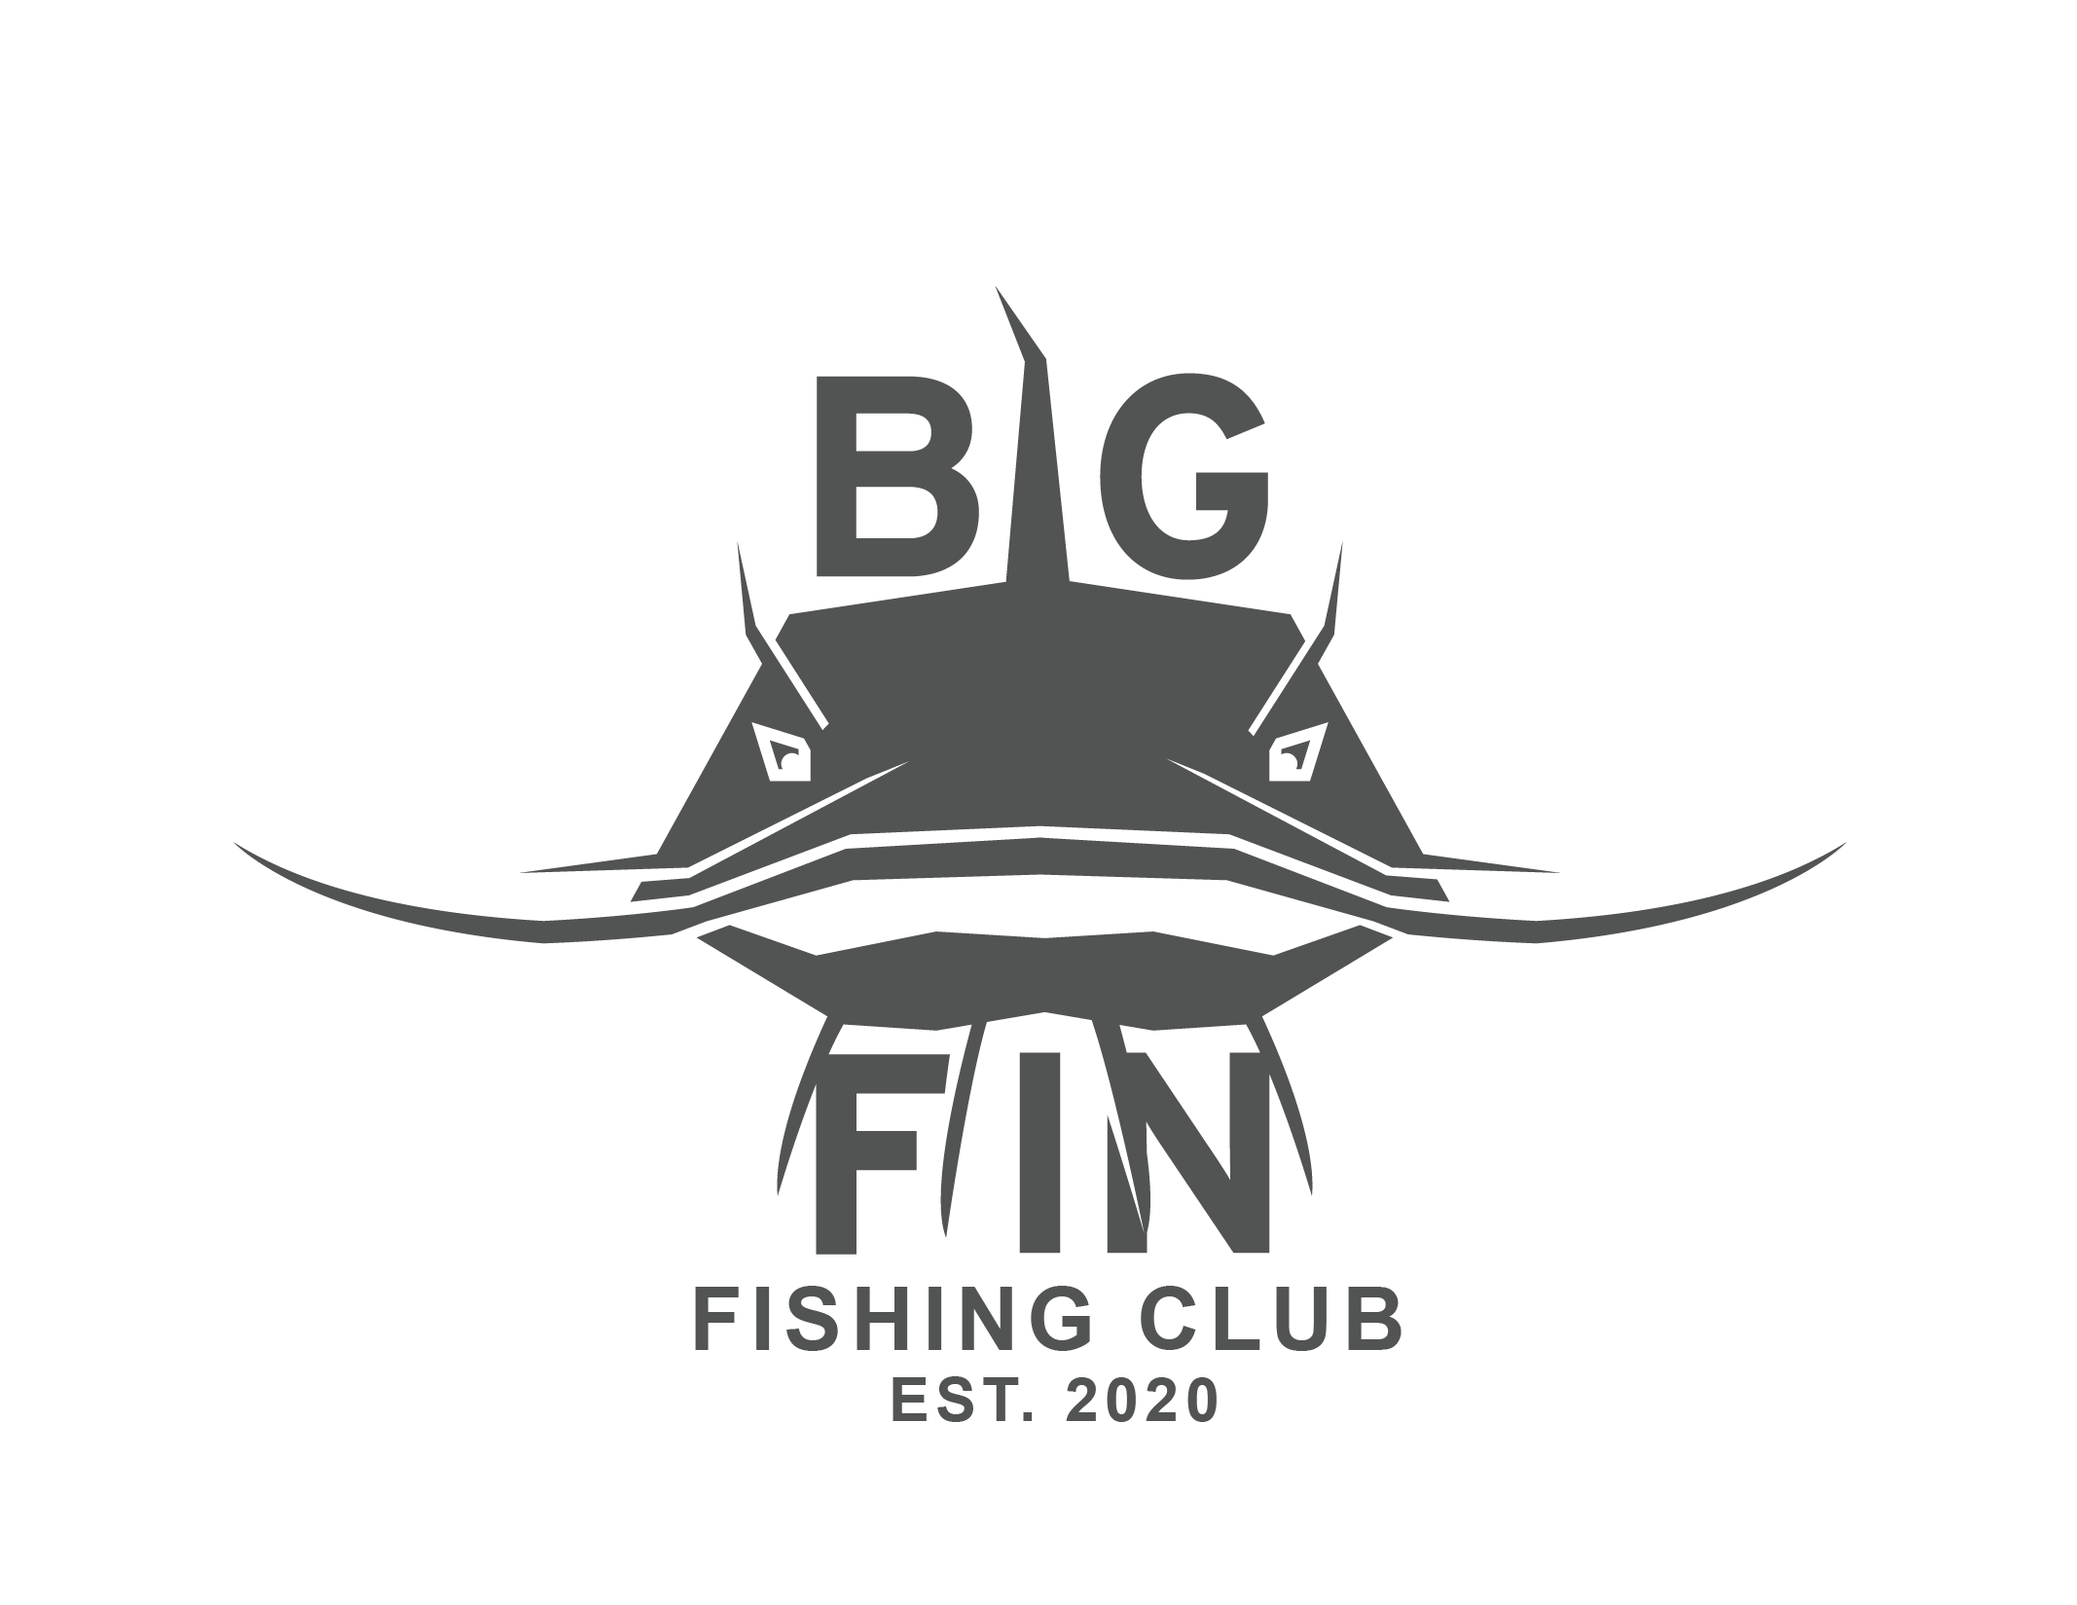
    - Wednesdays
  2nd- 5th graders
  This faith-based volleyball class was designed by a local Head Volleyball Coach. This class will expose your child to the fundamentals of volleyball or improve known skill. Come join us!
  Sign up Here:
  
  
  Volleyball
  G
  G
  Do not miss all of the fun!
  this class will be lead by Local High school volleyball players
  challenge a friend to join with you!
  $265 for 11(2/5-4/22) weeks
  BIG FIN
  Zack Cook
  For any questions, please email
  bigfinfishingapparel@gmail.com
  Venmo: @Zack-cook-18

