  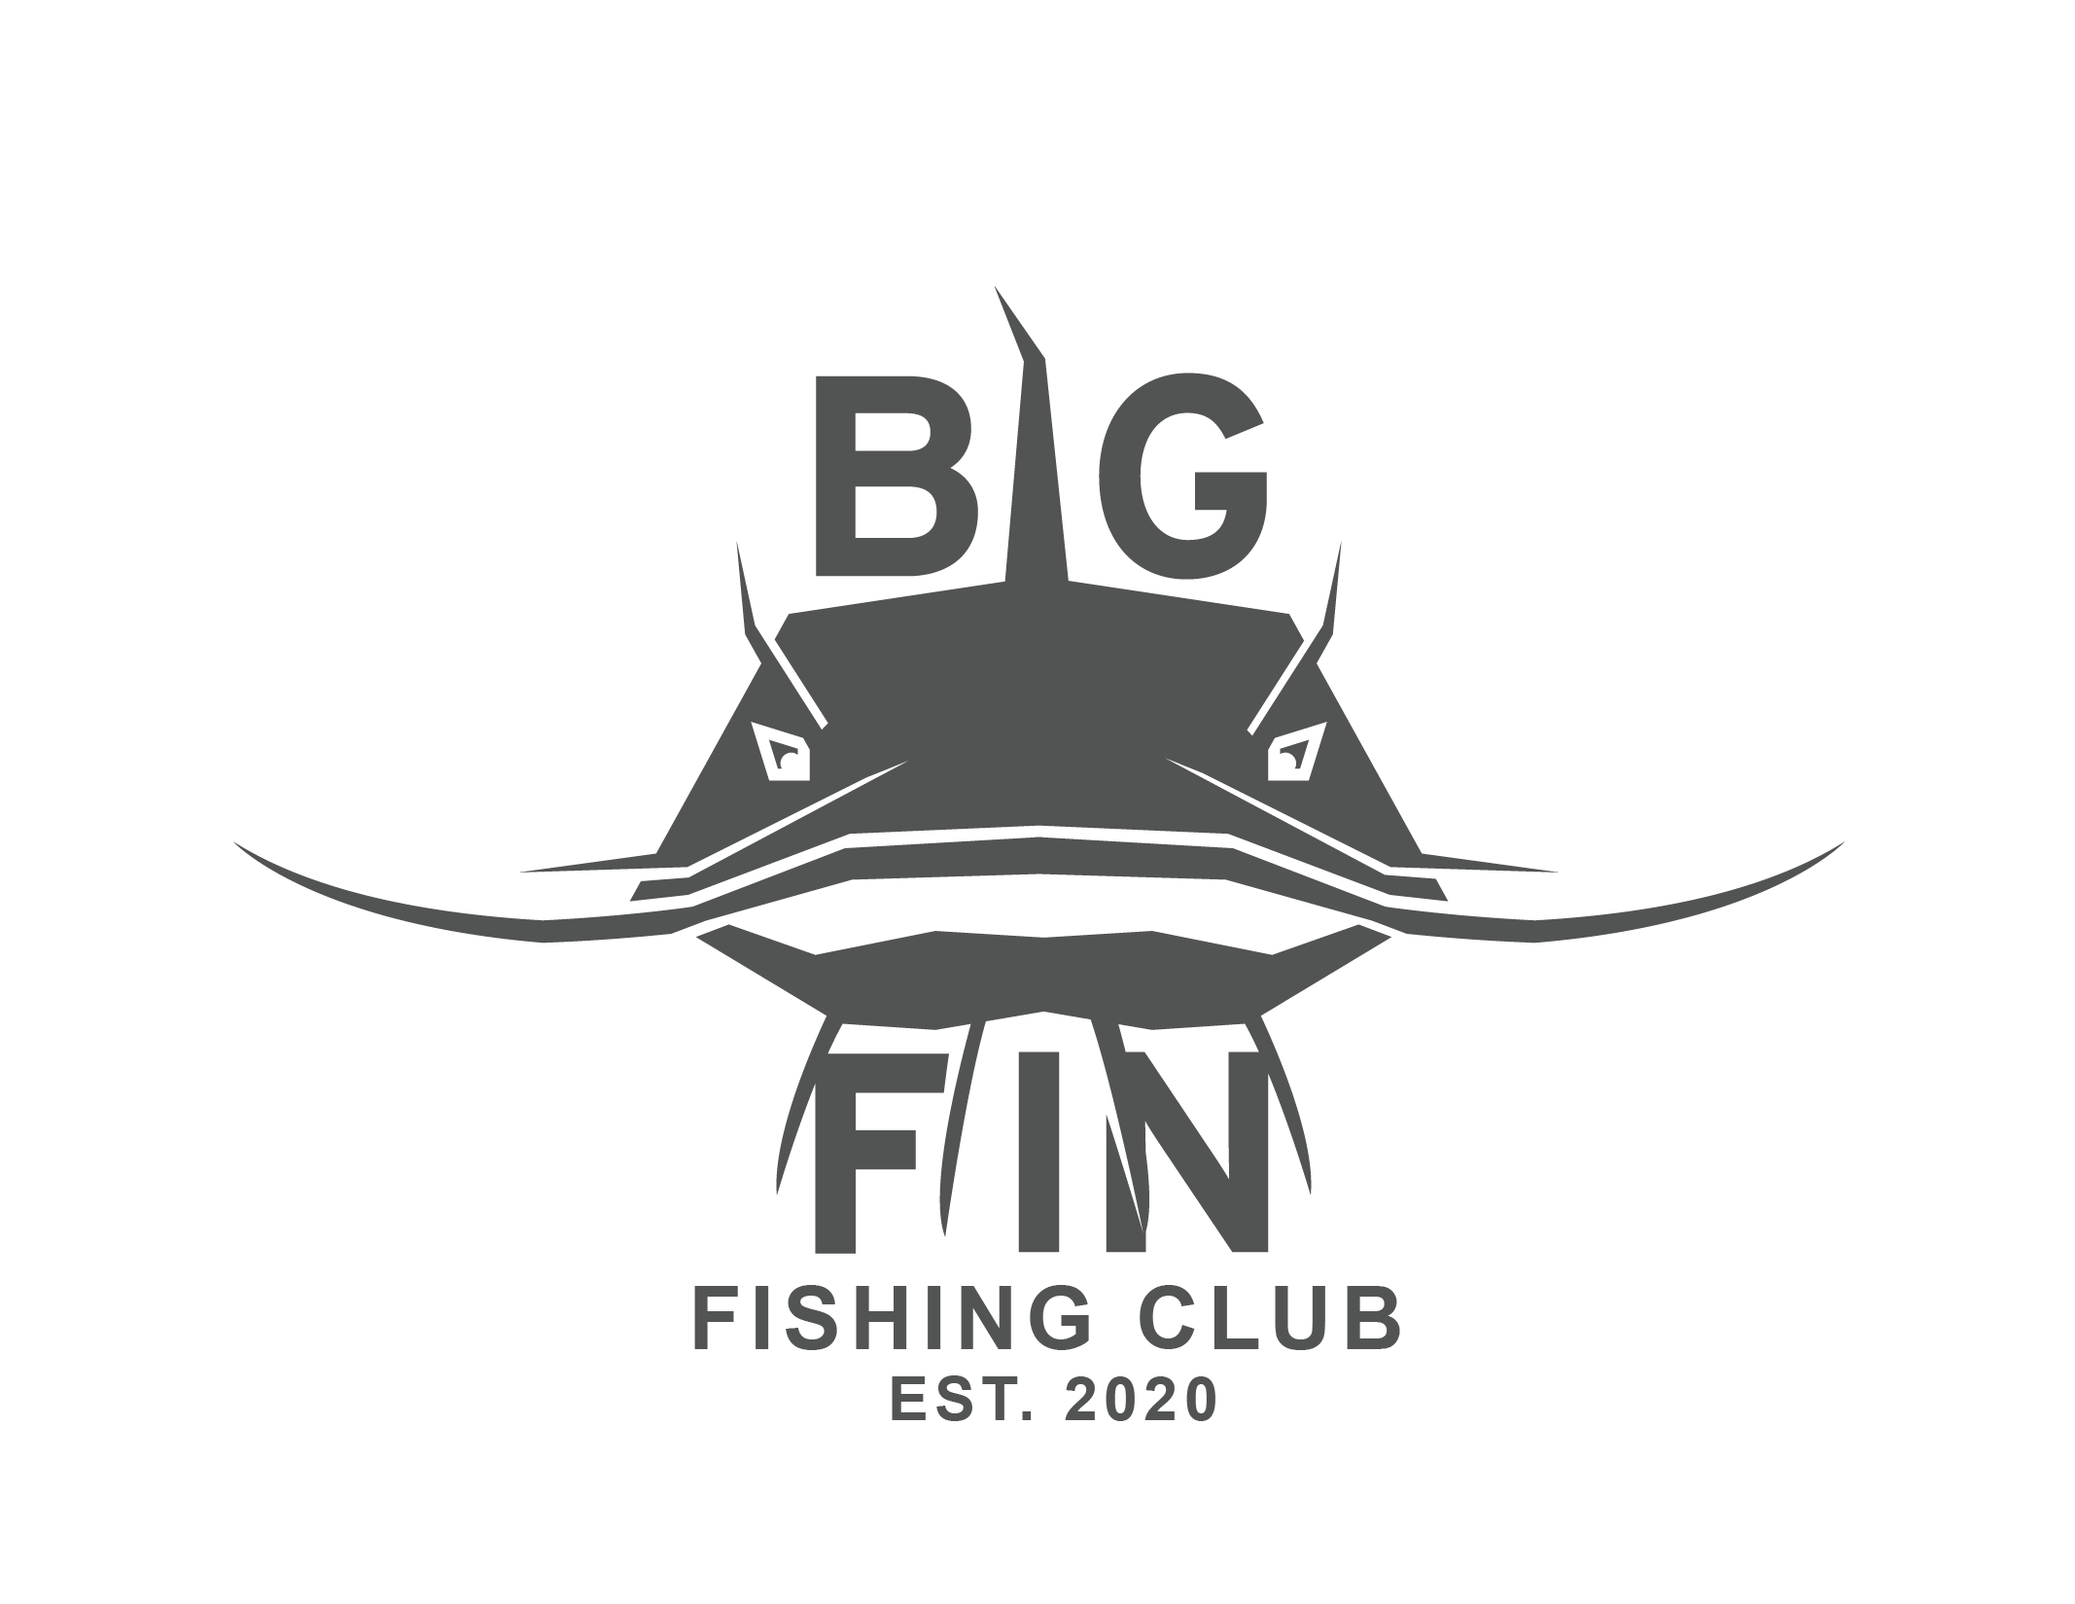
    - Thursdays
    - 3rd 4th and 5^{th graders}
  11 weeks (2/5-4/23)
  Big Fin Outdoors is a faith based class that follows the life of Jesus and his Disciples. The students will learn about fishing and how to cast, tie knots, throw casting nets, and do several other exciting activities.
  Sign up Here See What Were About
  Sign up Here See What We Are About 
  See promo video
  
  BIG FIN OUTDOORS
  Don’t miss all of the fun! Tent pitching, Casting, hook tying, archery, planting, harvesting, etc.
  optional annual white water rafting trip for big fin participants and parents
  We have a blast exploring the outdoors together and creating community
  $265
  Big FIn
  Zack Cook
  Bigfinfishingapparel@gmail.com
  Venmo: @Zack-Cook-18

